Amazon Elastic computing cloud(EC2) is a part of Amazon Web services(AWS) which allows the users to access the virtual computers of in which they can run their own applications. It offers the broadest and deepest computing platform which has over 500 choices of the newest launched processor, storage capacity type, and the type of various operating systems. It is basically a virtual machine which is designed to handle the variety of workloads. It has a huge scalable computing technology, and this will allow the organizations to develop their product and they can deploy easily because the amazon cloud is faster, and they have a huge variety of cloud networks which can deploy the organization product to any part of the world.

* Main Features of Amazon EC2

1. Amazon offers very reliable environment where it do the service level agreement with the client of the availability of their EC2 model in the region selected by the client.
2. Amazon cloud is very secure and vast network of resources. So, it protects the data, and it makes the stored data secure.
3. The EC2 model offered by amazon is cheaper compared to other various because it uses the special price model which charges the company only for the resources they use.

* How EC2 helps in application deployment?

Amazon uses the special software for the deployment of the applications in the amazon EC2 instances. This software is known as Code Deploy it is a deployment service which works automatically in deploying the application content that runs on a server and it can also deploy new features. It helps in avoiding the downtime during the deployment of the newer versions. Hence, the application deployment using the Amazon EC2 model is easy to adopt because companies can easily reuse the code and it gives the ability to the companies to stop the latest version and revert it back to the previous versions in case it there is any errors in the system.

*Photo retrieved from:* [*https://www.tutorialspoint.com/amazon_web_services/amazon_web_services_basic_architecture.htm*](https://www.tutorialspoint.com/amazon_web_services/amazon_web_services_basic_architecture.htm)

[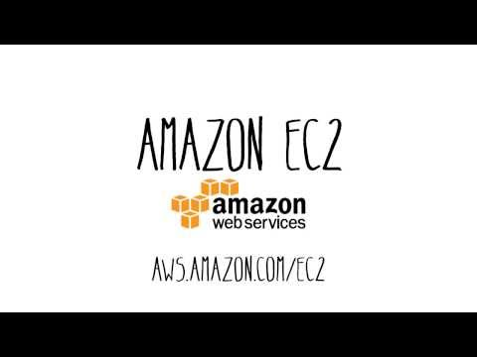](https://www.youtube.com/embed/TsRBftzZsQo?feature=oembed)

*Source: https://www.youtube.com/watch?v=TsRBftzZsQo*

* **References**

Amazon. (n.d.). Amazon EC2: Amazon Elastic Compute Cloud: Amazon Web Services. Amazon Web Services, Inc. Retrieved April 15, 2022, from https://www.amazonaws.cn/en/ec2/